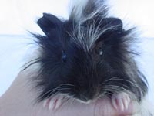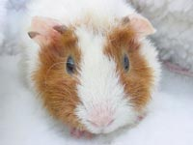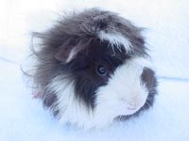

Help the Hollister Homeless Piggies

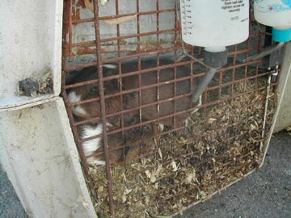
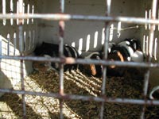
July 2nd Hollister Animal Control seized 187 guinea pigs from a breeder. They were caged outdoors on never-cleaned, maggot-infested bedding crammed in dog crates. Many females are pregnant. The guinea pigs are now being housed at the Peninsula Humane Society in San Mateo under the care of Cavy Spirit, an all-volunteer guinea pig rescue group. We need help funding their care, with feeding and cleaning, and finding good homes for these sweet animals.
Guinea pigs are not just for kids! Guinea pigs make wonderful pets for adults, too. We will be adopting them out in non-breeding pairs or for a friend for an existing guinea pig. There is a $25 adoption fee per guinea pig (which goes to the rescue to help support all of the guinea pigs) and very nice, inexpensive cages are available for purchase. Adoptions are through Cavy Spirit and not the shelter. Please call 650-571-1722 or visit www.CavySpirit.com for info about how you can help!
http://www.cavyspirit.com/hollister.htm
Call CavySpirit (650) 571-1722
http://www.cavyspirit.com/hollister.htm
Call CavySpirit (650) 571-1722
http://www.cavyspirit.com/hollister.htm
Call CavySpirit (650) 571-1722
http://www.cavyspirit.com/hollister.htm
Call CavySpirit (650) 571-1722
http://www.cavyspirit.com/hollister.htm
Call CavySpirit (650) 571-1722
http://www.cavyspirit.com/hollister.htm
Call CavySpirit (650) 571-1722
http://www.cavyspirit.com/hollister.htm
Call CavySpirit (650) 571-1722
http://www.cavyspirit.com/hollister.htm
Call CavySpirit (650) 571-1722
http://www.cavyspirit.com/hollister.htm
Call CavySpirit (650) 571-1722
http://www.cavyspirit.com/hollister.htm
Call CavySpirit (650) 571-1722
http://www.cavyspirit.com/hollister.htm
Call CavySpirit (650) 571-1722
http://www.cavyspirit.com/hollister.htm
Call CavySpirit (650) 571-1722
http://www.cavyspirit.com/hollister.htm
Call CavySpirit (650) 571-1722
http://www.cavyspirit.com/hollister.htm
Call CavySpirit (650) 571-1722
http://www.cavyspirit.com/hollister.htm
Call CavySpirit (650) 571-1722

